CENWP-OD-B 07 October 2010

MEMORANDUM FOR THE RECORD

SUBJECT: Dead chinook at Bonneville’s Adult Fish Facility (AFF).

On 07 October at approximately 0945 hours, CRITFC researchers called Project Fisheries to report a chinook mortality in the AFF. The fish was discovered on the Valve 15 return pool drain trash rack while CRITFC was starting up the lab. The fish had a notable injury on one side. It had not been sampled by CRITFC. The fish was disposed of down drain valve 15 in the AFF at approximately 1015 hours. Information collected is provided below:

- Species – Chinook female
- Origin – Unclipped
- Length – 85 cm
- Marks and tags – None
- Marks and Injuries found on carcass – Possible pinniped injury
- Cause and Time of Death – Unknown, possibly due to injury
- Future and Preventative Measures – N/A

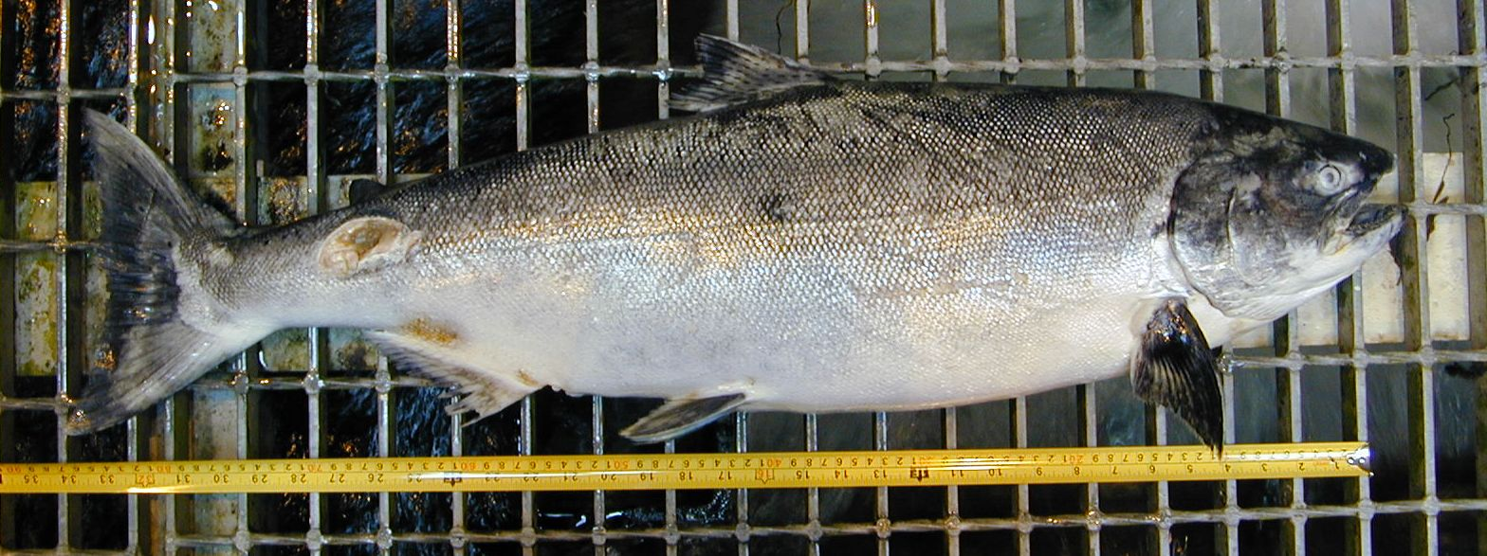

Bonneville Fisheries

